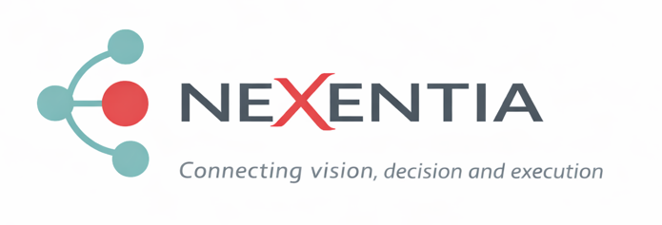

Strategic Consulting & Business Scalability 360º

Corporate Profile 2026

Strategy · People · Technology · Sustainable Growth

“Partnering with growing companies to define direction, strengthen operations and scale sustainably.”

📍 Madrid · Barcelona
📧 miguel.ibarra@nexentia360.com
🌐 www.nexentia360.com
📊 Diagnóstico360º: www.nexentiaconsulting360/diagnostico360.com

Who We Support and Why It Matters
Growing organisations operate in an environment shaped by structural uncertainty, accelerated transformation and sustained pressure to deliver profitable, sustainable growth.
Many companies reach a pivotal inflection point: the business model has proven viable, yet complexity begins to outgrow organisational structure, and key decisions are made without sufficient perspective, challenge or governance.
At this stage, NeXentia Consulting brings senior executive judgment, strategic architecture and rigorous execution discipline.
We work alongside leadership teams and boards to restore strategic clarity, strengthen decision-making frameworks and enhance forward-looking capability across the business functions that underpin scalable performance.
Our engagement model is intentionally selective, limited to a maximum of three to four concurrent mandates, ensuring depth of involvement, senior-level attention and measurable value creation.
Value Proposition
We partner with SMEs and growing companies to scale with purpose, integrating strategy, people and technology to drive sustainable growth.
Why NeXentia | What This Means for Clients
Senior Executive Track Record | Over 30 years leading national and international organisations, translating strategic vision into operational execution.
Selective Engagement Model | A deliberately selective model to ensure maximum dedication and high-quality oversight.
Structured Advisory Approach | Clear framing, practical action plans, KPIs, executive follow-up and accountability adapted to each mandate.
Evidence of Impact | Results-focused work aimed at improving efficiency, growth and profitability, with impact varying by scope and implementation.
Holistic Perspective | Integration across strategy, operations, finance, commercial and people through the Red Core Thread approach.

The Red Core Thread — The Foundation of Scalability
The Red Core Thread is the strategic backbone that connects the core processes of strategy, operations, finance, marketing & sales, and people — ensuring that decisions in one area do not create friction in another, preventing disconnects between strategy and functional execution, as well as overlaps or gaps across functions. This approach enables organizations to:
- Build interconnected and coherent processes
- Identify and resolve critical inefficiencies with speed
- Align all departments under a single, unified strategic roadmap
Result: less improvisation, fewer silos, and greater execution speed with governance and control.
Strategic Scope Across Core Functions
Our work combines strategic vision, operational rigor and organisational development.
We support companies across five essential areas of sustainable growth, applying an integrated perspective so that decisions in one function reinforce the others.

Corporate Strategy
- Mission, Vision and Purpose definition
- 3–5 years strategic planning
- Business model scaling and growth structures
- Identification of corporate synergies
- Post-M&A integration
- International expansion processes
Objective: Strategic clarity and organisational coherence.

Finance & Control
- Cash-flow management and treasury forecasting
- Financial KPIs and executive dashboards
- Administrative and control process automation
- Scalable financial structure design
Objective: Data-driven decisions and real business control.

Operations
- Optimisation and standardisation of key processes
- Continuous improvement and lean management principles
- Cross-functional alignment
- Pragmatic application of AI and intelligent automation
Objective: Operational efficiency and true growth capacity.

Marketing & Sales
- Value proposition and positioning
- Results-oriented marketing plans
- Customer acquisition models (new products and/or markets)
- Commercial model and incentive design
- Conversion and profitability KPIs
Objective: Turning strategy into commercial traction.

People, Culture & Leadership
- Organisational design and team structures
- Executive coaching and talent development
- Change management
- Team alignment and engagement
- High-performance, purpose-driven culture building
Objective: Talent as the engine of scalability.

Our Services
Strategy, judgment and execution for growing organisations.
We support executive teams in strategic decision-making, growth processes and disciplined strategy execution.
Our offering is structured into three differentiated services designed for distinct company stages. The Red Core Thread informs all mandates as an integration lens, while the full governance cadence and execution architecture are deployed primarily in Strategic Partnership engagements.

Strategic Project Consulting
Addressing a specific strategic challenge
Designed to resolve a clearly defined strategic issue with a structured scope and concrete objective. Appropriate when:
- A specific strategic decision is required
- The challenge is clearly delimited
- Rigorous analysis and clear recommendations are needed
Role: Senior strategic consultant per project.
Examples include commercial model redesign, organisational restructuring, post-acquisition integration planning, or entry into a new market.

Connecta®
Strategic judgment on demand
On-demand strategic advisory service for leadership teams requiring ongoing contrast, perspective and clarity without launching a formal project. Not execution. Not deliverables. Senior strategic perspective available when needed. Appropriate when:
- Strategic decisions arise frequently
- An external strategic sparring partner is needed
- Speed and focus are critical
Role: Senior strategic advisor on demand.
Typical use cases include preparing critical decisions, challenging investment priorities, reviewing leadership alignment, or stress-testing growth options.

Strategic Partnership
Design and execution of strategy
Comprehensive design and deployment of a global strategic plan, with ongoing executive support to ensure focus, cross-functional alignment and disciplined execution.
Appropriate when:
- Growth becomes complex
- Significant directional shifts are underway
- Ongoing discipline and structured follow-up are required
Role: Strategic partner to executive leadership.

Service Comparison

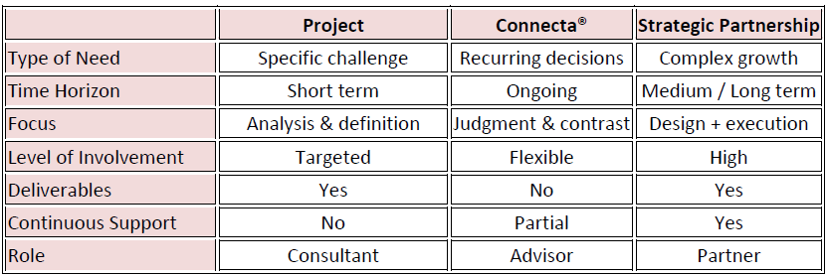

How They Relate
The services are not competing alternatives; they are complementary components of a coherent advisory model. Most clients initially engage through a specific project or a Connecta® mandate and progressively evolve toward a long-term strategic partnership model.
ROI & Evidence of Impact
Our work is designed to generate measurable and sustainable impact.
Across selected engagements, impact has typically translated into a strong return through improvements in efficiency, profitable growth and operational simplification. The exact return depends on the scope, starting point and implementation discipline of each client.
Illustrative benchmark: in many projects, each euro invested has generated a multiple in growth, efficiency or profitability. Specific results can be shared through relevant case discussions when appropriate.
How We Start
1. 360° Strategic Diagnostic
A focused initial assessment used selectively to understand the organisation’s starting point, strategic priorities and principal constraints. It is not a mass-assessment tool; it is deployed only when there is a realistic basis for further work. The output is a concise executive readout highlighting key issues, priority areas and recommended next steps.
2. 90/180-Day Scaling Roadmap
Definition of priorities, objectives and KPIs across key areas, where appropriate.
3. Executive Guidance
Structured collaboration with leadership and teams to ensure focus and execution discipline.
4. Quarterly Measurement & ROI Review
Impact tracking, performance evaluation and continuous plan adjustment in longer-term engagements.
Diagnostic available upon request.
Commitment and Working Principles
We intentionally limit the number of active clients and projects to a maximum of 3-4, ensuring full dedication, excellence and tangible return.
We support organisations across the growth cycle through diagnosis, strategy and execution, with the level of intervention adapted to each mandate.

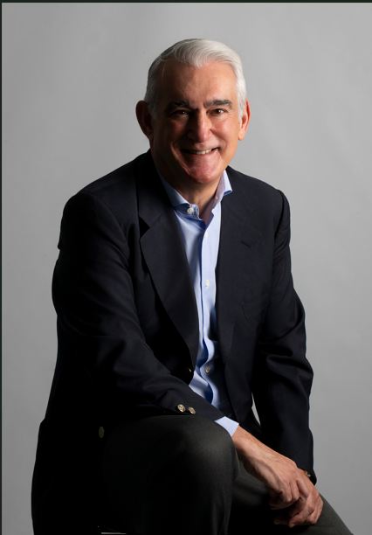
Miguel Ibarra — Managing Partner NeXentia Consulting

Executive and advisor with more than 30 years of national and international experience supporting organisations through transformation, growth and professionalisation across both B2B and B2C sectors (Life Sciences, chemical industry, FMCG and Real Estate).
Throughout his career, he has contributed to profitable growth, international expansion and structural professionalisation, enabling companies to evolve toward more efficient, scalable operating models.
His professional trajectory spans primarily Europe and Latin America, with additional experience in the United States and Asia. He combines global perspective with hands-on execution adapted to diverse organisational cultures — from multinational corporations to growth-oriented SMEs — successfully transferring expertise in both directions through the effective management of the three fundamental pillars of any organisation: People, Processes and Systems.
This combination provides a balanced strategic and operational perspective, bridging executive vision with disciplined implementation.
He has led and participated in business creation, scaling and integration processes, as well as transformation and performance improvement initiatives across numerous organisations, including Permobil, Hill-Rom/Baxter, B. Braun, Palex Group, Boehringer Ingelheim, 3M and Toyobo Group, among others.
Through NeXentia Consulting, he partners with SMEs and scale-ups seeking to structure and accelerate their growth, designing strategies and operational frameworks supported by people and systems that enable sustainable scalability. His objective is to place his national and international experience at the service of each organisation, generating tangible and measurable value.
He holds an MBA from IESE Business School and has completed executive education programmes at IESE, London Business School, SDA Bocconi, Copenhagen Business School, EAE and Yale University. In parallel with his advisory activity, he lectures and provides executive coaching, supporting leaders and teams in strengthening strategic capability and leadership effectiveness.
🔗 LinkedIn: www.linkedin.com/in/miguel-ibarra-consulting

Key Qualities Recognised by Colleagues and Partners
- People-centric, empathetic leadership
- Strategic excellence and strong business acumen
- Development of high-performing teams
- Transformation and change leadership
- Integrity, respect and professionalism

Selected Testimonials

Josef Selinger – Managing Director
“I have gotten to know Miguel Ibarra as a colleague in the EU Management Team and found him a very ambitious, focused, results driven and empathic leader, a great partner to assess common business challenges and a great person to consult with on many topics.
His combination of business accumen, international experience and medical background makes him an ideal fit for leadership positions in the medical device environment.”

Peter Moss – Chief Revenue Officer
“Having worked along side Miguel whilst we were both working for Hillrom I can only admire the professionalism that he demonstrated. Result focused, driven, and strategic in his view, but the thing most noticeable was the admiration that his team had for him.
Miguel constantly demonstrated that results came from his team — the ability to bring others on our journey is vital and clearly evident in Miguel’s team relationships.”

Lucas Varela – Head of Talent & Development Solutions
“Podéis conocer mucho a una persona por cómo trata a quienes se supone que están por debajo de él. He trabajado con Miguel en varios procesos de selección para su organización, y es un profesional talentoso y una gran persona. Respeta y valora el trabajo de los demás, pero también sabe marcar límites cuando es necesario. Es diligente, transparente y colaborador. Un líder nato. Ojalá sigamos trabajando juntos en el futuro.”

Simona Crea – Strategic Marketing Manager
“Miguel è stato il mio responsabile diretto per diversi anni, dimostrando una leadership forte e coraggiosa. Un manager attento che ha saputo conseguire risultati finanziari importanti, guidando l’azienda e il suo team attraverso un percorso di cambiamento significativo.
Sempre pronto ad ascoltare, guardando al futuro con mente aperta e senza mai perdere di vista la big picture. Integrità, rispetto e coraggio nel prendere decisioni strategiche sono gli aggettivi che meglio rappresentano Miguel. Lavorare con lui è stata per me un’esperienza molto positiva.
Juan Marcos – Partner- Director

“Tuve la oportunidad de colaborar con Miguel por primera vez en su etapa de Director General en Hillrom en proyectos de desarrollo competencial de su equipo directivo en los ámbitos de la innovación y la estrategia. Miguel cuenta con una trayectoria profesional impecable, una mentalidad global y un liderazgo natural que le permite orientar a su equipo a la consecución de resultados, facilitando además su desarrollo y crecimiento.”

